**Network Forensic Analysis Report**  **## Time Thieves ## You must inspect your traffic capture to answer the following questions:** 1. What is the domain name of the users custom site? -frank-n-ted.com 2. What is the IP address of the Domain Controller (DC) of the AD network? -10.6.12.12  **Both of these answers can be found here:**```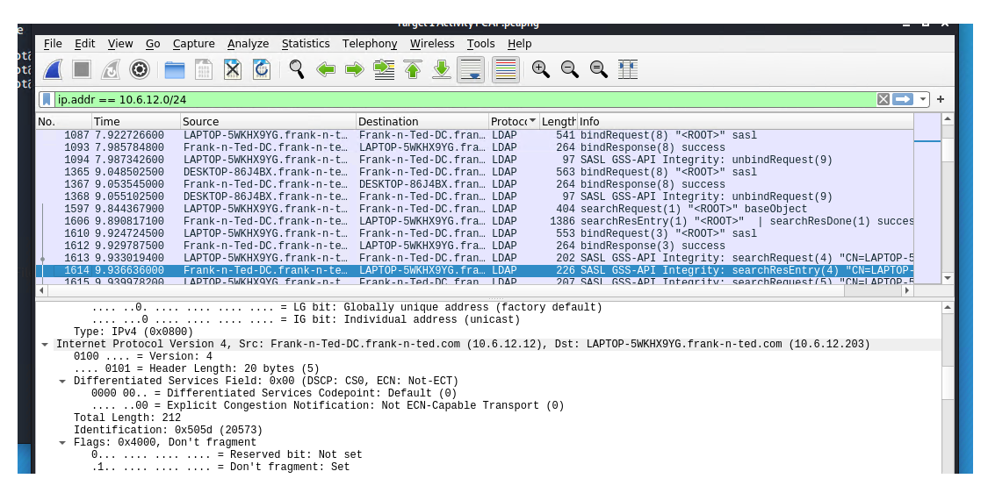 3. What is the name of the malware downloaded to the 10.6.12.203 machine? -June11.dll

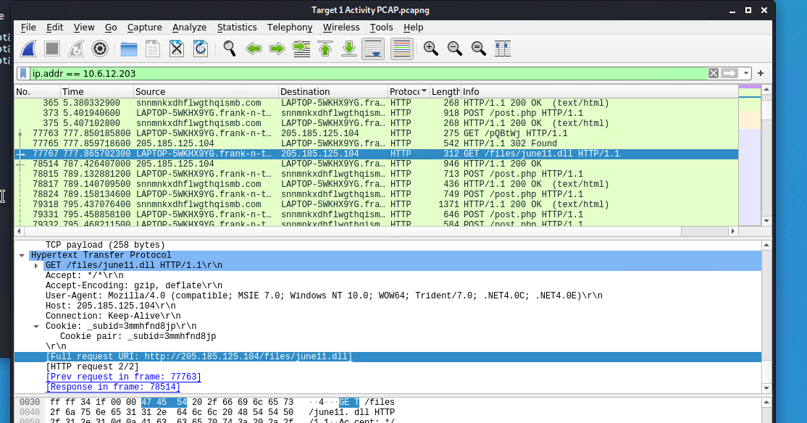  **## Once you have found the file, export it to your Kali machine's desktop. ##Upload the file to [VirusTotal.com](https://www.virustotal.com/gui/).** 5. What kind of malware is this classified as? -Trojan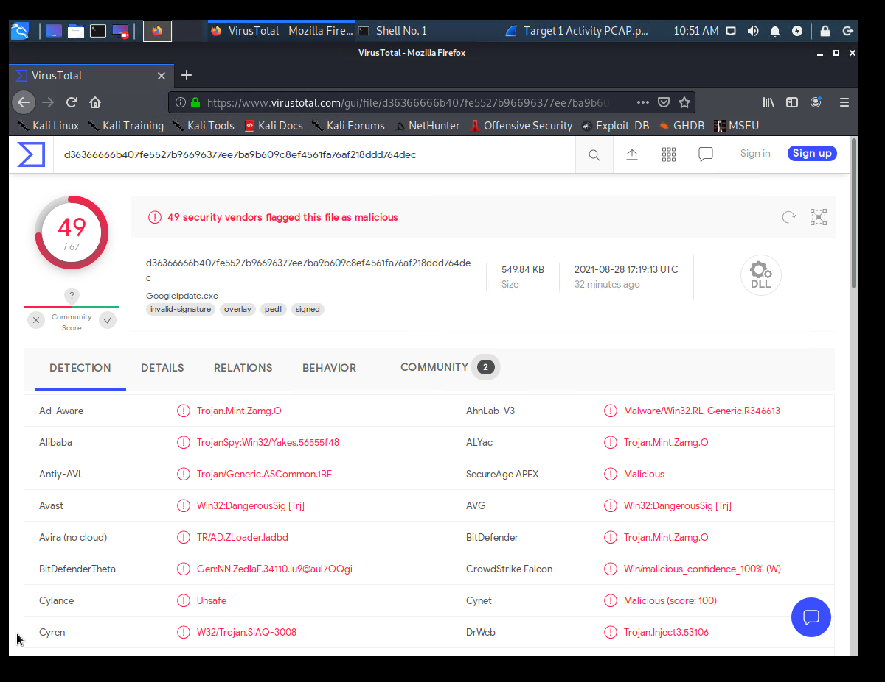 **Vulnerable Windows Machine** 1. Find the following information about the infected Windows machine: - Host name: ROTTERDAM-PC - IP address: 172.16.4.205 - MAC address: 00:59:07:b0:63:a4 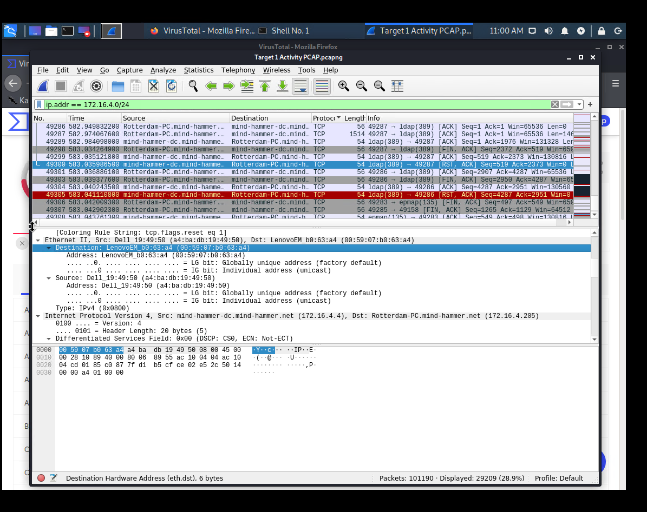 2. What is the username of the Windows user whose computer is infected? -mattijs.devries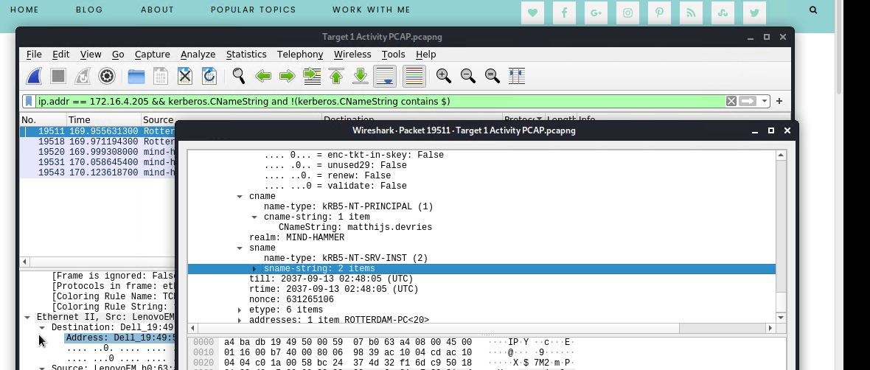 3. What are the IP addresses used in the actual infection traffic? -185.243.115.84 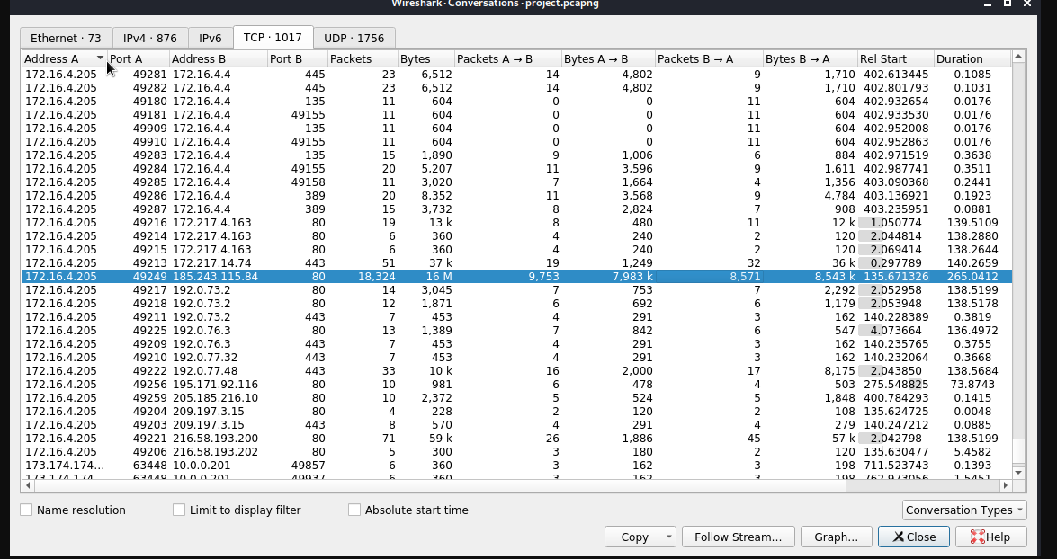---**## Illegal Downloads** 1. Find the following information about the machine with IP address `10.0.0.201`: - MAC address: 00:16:17:18:66:c8 - Windows username: elmer.blanco

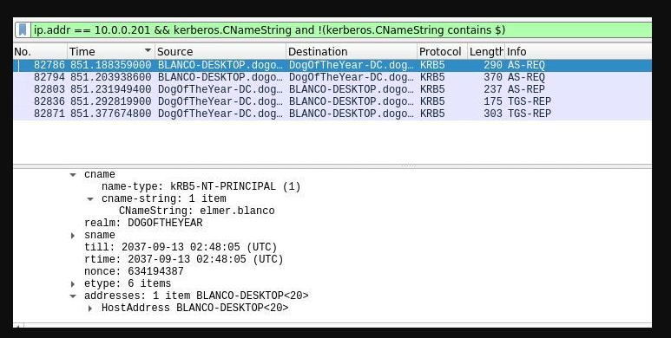

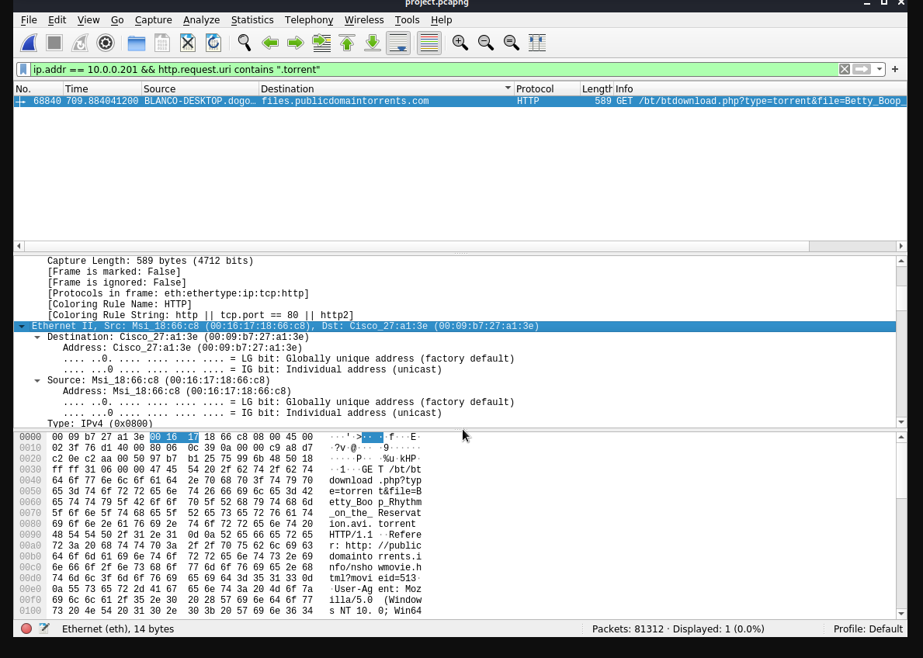 2. Which torrent file did the user download? - Betty_Boop_Rhythm_on_the_Reservation.avi.torrent

